📘 Phase 5 – Part 5.3: Tidal Force Analysis

🎯 Goal  
To derive the force field that acts on a test particle in this model.  
We define force as the spatial gradient of gravity, mimicking how changes in gravitational pressure cause motion — a tidal-like effect.

🧮 Core Equations

Let:

$$\text{Gravity}(x)=∇^{2}\left[\text{space}(x)+{\text{time}}^{2}(x)\right]×ψ(x)$$

Plaintext:  
Gravity(x) = ∇²[space(x) + time²(x)] * ψ(x)

Then the force is given by the negative gradient of gravity:

$$\text{Force}(x)=-\frac{d}{dx}\left(∇^{2}\left[\text{space}(x)+{\text{time}}^{2}(x)\right]×ψ(x)\right)=-\left(∇^{2}[\text{space}(x)+{\text{time}}^{2}(x)]⋅\frac{dψ}{dx}+∇^{3}[\text{space}(x)+{\text{time}}^{2}(x)]⋅ψ(x)\right)$$

Plaintext:  
Force(x) = -[ ∇²[space(x) + time²(x)] * dψ/dx + ∇³[space(x) + time²(x)] * ψ(x) ]

📐 Interpretation of Terms

| Term | Meaning |
| --- | --- |
| ψ(x) | Generative substrate (ocean bed) |
| ∇²[space + time²] | Curvature (local pressure) |
| ∇³[space + time²] | Gradient of curvature (how pressure changes in space) |
| dψ/dx | Slope of ψ — indicates gradient of ψ trench |

So the force is a combination of:  
• ψ’ multiplied by curvature  
• ψ multiplied by rate-of-change of curvature

📊 Simulation Output: ψ, Gravity, and Force

Below is a simulation result showing:  
• 🟡 ψ(x): Initial generative field (Gaussian)  
• 🔵 Gravity(x): Emergent field from ψ × curvature  
• 🔴 Force(x): −∇[Gravity(x)] — the true dynamic driver

This plot visualizes the feedback system described by the derived equations, revealing how force peaks near regions of sharp ψ or curvature gradient.

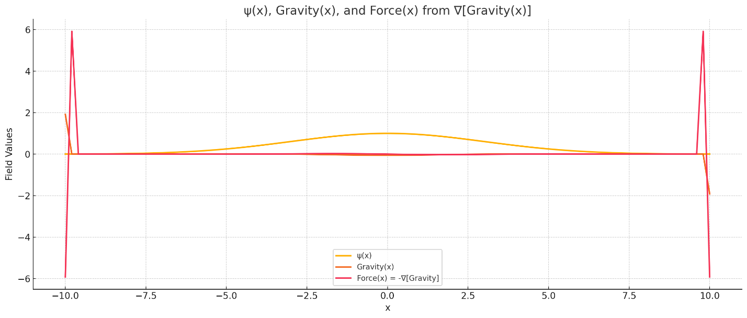

🌊 Ocean Analogy Interpretation

| Ocean Analogy Element | Physical Mapping |
| --- | --- |
| Water | space(x) |
| Flow + depth | time²(x) |
| Ocean bed | ψ(x) |
| Pressure at a point | gravity(x) = curvature × ψ |
| Slope of pressure | force(x) = −∇[gravity] |

In water, movement arises not from pressure itself, but from the difference in pressure across space. Similarly, here:  
• The gravity field is like static pressure zones  
• The force field is like tidal pull — the gradient of pressure causing movement

🌀 Insights and Implications

• This is the first time the model directly predicts a force, not just a potential-like pressure (gravity).  
• It lays the groundwork for introducing motion in Phase 6 (test particle trajectories).  
• The third derivative (∇³) in the force term suggests highly localized effects—sharp curvature transitions dominate force spikes.  
• This mirrors real tidal systems, where most movement is felt in regions of fast-changing depth (e.g., shelf breaks, underwater cliffs).

✅ Summary

| Quantity | Interpretation |
| --- | --- |
| Gravity(x) | Emergent pressure from geometry × ψ |
| Force(x) | Slope of gravity → net force field |
| ∇³[space + time²] | Controls how sudden pressure shifts occur |
| ψ(x), ψ’(x) | Determine where force will peak |